**Design and implement a small office**

**Network Requirements Definition:**

* Users : 10-15 users per branch (2 branches).
* Devices: Routers and switches (Cisco), computers, printers.

**Topology Diagram:**

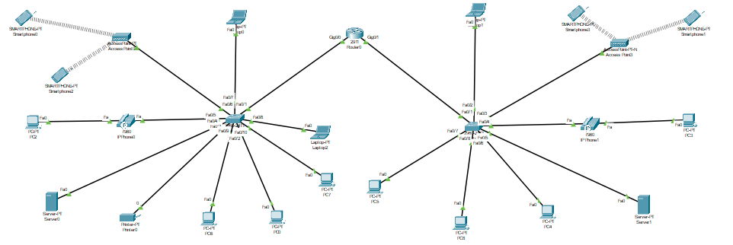

**IP Addressing Scheme:**

* **VLAN 10 ( IT ) :**
* Switch 1: port f0/7 subnet>>>192.168.2.0>>GigabitEthernet0/0.10
* Switch 2: port f0/2 subnet>>>172.16.2.0>>GigabitEthernet0/1.10
* **VLAN 20 ( CS ) :**
* Switch 1: port f0/2 subnet>>>192.168.6.0>>GigabitEthernet0/0.20
* Switch 2: port f0/7 subnet>>>172.16.7.0>>GigabitEthernet0/1.20
* **VLAN 30 ( IS ) :**
* Switch 1: port f0/9 subnet>>>192.168.9.0>>GigabitEthernet0/0.30
* Switch 2: port f0/6 subnet>>>172.16.5.0>>GigabitEthernet0/1.30
* **VLAN 40 ( HR ) :**
* Switch 1: port f0/5 subnet>>>192.168.7.0>>GigabitEthernet0/0.40
* Switch 2: port f0/4 subnet>>>172.16.4.0>>GigabitEthernet0/1.40
* **VLAN 50 ( Sales ) :**
* Switch 1: port f0/10 subnet>>>192.168.5.0>>GigabitEthernet0/0.200
* Switch 2: port f0/8 subnet>>>172.16.6.0>>GigabitEthernet0/1.50
* **VLAN 60 ( manager ) :**
* Switch 1: port f0/8 subnet>>>192.168.4.0>>GigabitEthernet0/0.60
* **VLAN 80 ( access point ) :**
* Switch 1: port f0/6 subnet>>>192.168.8.0>>GigabitEthernet0/0.80
* Switch 2: port f0/3 subnet>>>172.16.3.0>>GigabitEthernet0/1.80
* **Native vlan 100**
* **Vlane voice 150**

**DHCP Servers**

* **VLAN 10 pool :**
* Switch1>>>Default-gateway: 192.168.2.1>> Start IP: 192.168.2.10
* Switch2>>>Default-gateway: 172.16.2.1>> Start IP: 172.16.2.10
* Subnet-Mask: 255.255.255.0
* **VLAN 20 pool :**
* Switch1>>>Default-gateway: 192.168.6.1>> Start IP: 192.168.6.10
* Switch2>>>Default-gateway: 172.16.7.1>> Start IP: 172.16.7.10
* Subnet-Mask: 255.255.255.0
* **VLAN 30 pool :**
* Switch1>>>Default-gateway: 192.168.9.1>> Start IP: 192.168.9.10
* Switch2>>>Default-gateway: 172.16.5.1>> Start IP: 172.16.5.10
* Subnet-Mask: 255.255.255.0
* **VLAN 40 pool :**
* Switch1>>>Default-gateway: 192.168.7.1>> Start IP: 192.168.7.10
* Switch2>>>Default-gateway: 172.16.4.1>> Start IP: 172.16.4.10
* Subnet-Mask: 255.255.255.0
* **VLAN 50 pool :**
* Switch1>>>Default-gateway: 192.168.5.1>> Start IP: 192.168.5.10
* Switch2>>>Default-gateway: 172.16.6.1>> Start IP: 172.16.6.10
* Subnet-Mask: 255.255.255.0
* **VLAN 60 pool :**
* Switch1>>>Default-gateway: 192.168.4.1>> Start IP: 192.168.4.10
* Subnet-Mask: 255.255.255.0
* **VLAN 80 pool :**
* Switch1>>>Default-gateway: 192.168.8.1>> Start IP: 192.168.8.10
* Switch2>>>Default-gateway: 172.16.3.1>> Start IP: 172.16.3.10

**Device List :**

* **1 Cisco Router 2911**
* **2 Cisco Switch 2960 IOS15**
* **10 – 15 PC per branch**
* **2 Cisco Access point AP-PT**
* **4 SmartPhones**